

I created / adapted a total of 10 questions, some with a little Naruto or FRIENDS context (SPOILERS ALERT)

You may use any methods to solve these questions, although I would encourage you to stick to conventional solutions taught in class. **Do NOT import** any modules unless specified. **Refrain from using Google**; you can’t do that in the Lab Test anyway.

As you code, try to **time yourself** to solve it as fast as possible. The following timings are suggested for each difficulty:

|  |  |
| --- | --- |
| **One Star [*]** | 5 minutes or less |
| **Two Star [**]** | 5 to 20 minutes (depending on difficulty) |
| **Three Star [***]** | 20+ minutes, until your Lab Test time is up.  If you spend more than 30 minutes and are unable to solve / start, skip the question. |
| **Q10** | If you can solve this you deserve a gold medal. |

All the best for your Lab Test 2 & Finals revision!!

* **Stephen**

**--------------------------------------------------------------------------------------------------------------------------**

###### **Q1: Banned Characters**

**---------------------------------------------------------------------------------------------------------------------------**

[*] Part A) Implement a function called *banned_words* that takes in 2 parameters:

* a string, *banned_string (cannot be empty, lowercase only)*
* A list, *word_list* that contains several strings. *(can be empty)*

The function **returns** a list of words that contain the banned string. The words should

retain their original casing (they should keep their upper casing if any) If there are no words containing the banned string, the function returns an empty list.

You may assume that the words only contain alphabets.

[**] Part B) Write a program that prompts the user for a sentence and a banned string.

The program should print out the words in the user sentence that contains the

banned string. The words listed should **NOT** contain any punctuation, numbers,

Symbols. The words returned should contain its original uppercase (if any) or

lowercase characters if any.

Your output should look like this:

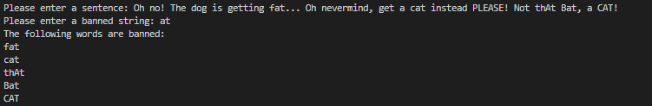

[**] Part C) Implement another function called banned_words2. The function takes in 2 parameters:

* A list of strings, *banned_list*. (can be empty)
* A list, *word_list* that contains several strings. (can be empty)

The function should return a list of words that contain either of the strings in the

*banned_list*. If there are no words containing either strings in the *banned_list*, the

function should return an empty list. You may assume the strings in *banned_list* are

ALL in lowercase, however you have to assume that each word has a mix of only

uppercase and lowercase characters in *word_list*. **There should be NO duplicated**

**words in your returned list**.

Write a program that prompts the user for a sentence, as well as banned strings that

are separated by a comma. You may assume that the format of the input for banned

strings is always correct, and that there are NO commas present in any string ( in

other words, commas are only used to separate each string in the input ).

Your output should look like this:

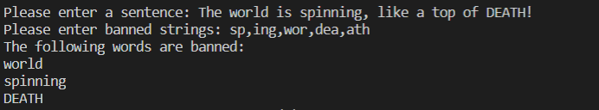

**---------------------------------------------------------------------------------------------------------------------------**

###### **Q2: Unique Words and Sorting**

**---------------------------------------------------------------------------------------------------------------------------**

[*] Write a function *unique_sort* that takes in *sentence*; a sequence of whitespace separated words as input and

**returns** the words after removing all duplicate words and sorting them alphanumerically.

The words returned should be **entirely in lowercase**, regardless of how it was inputted.

Refer to q2_function_test.py for sample input.

Adapted from: https://github.com/zhiwehu/Python-programming-exercises/blob/master/100%2B%20Python%20challenging%20programming%20exercises.txt

**---------------------------------------------------------------------------------------------------------------------------**

###### **Q3: Robot Movements**

**---------------------------------------------------------------------------------------------------------------------------**

[*] A robot moves in a plane starting from the original point (0,0). The robot can move toward UP, DOWN, LEFT and RIGHT with a given step.

Write a function called *compute_steps*, that takes in 4 parameters:

* *up*, zero or a positive integer
* *down*, zero or a positive integer
* *left*, zero or a positive integer
* *right*, zero or a positive integer

The function should compute and **return** the **distance from the final position and original point**. If the distance is a float, then round it off to 2 decimal places. Otherwise, distance should bereturned as an integer.

**Hint:** Use this formula in your code to solve. 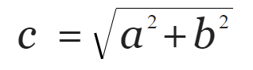

Adapted from: <https://github.com/zhiwehu/Python-programming-exercises/blob/master/100%2B%20Python%20challenging%20programming%20exercises.txt> (please don’t look at the solution here, the question has been MODIFIED)

**---------------------------------------------------------------------------------------------------------------------------**

###### **Q4: Get Alphabet String and Number**

**---------------------------------------------------------------------------------------------------------------------------**

[**] Write a function *get_alpha_num* that takes in a parameter *string*, where *string* can contain alphabets, symbols and integers.

The function returns a tuple containing 2 parameters:

* A new string that contains only alphabets. The order is based on the initial order of the alphabets in *string*.
* A number that represents the total addition and subtraction of all the integers in *string*. A number is subtracted when it contains a negative sign. (i.e. if “-5” is present in the string, 5 will be subtracted from the number. Note that you should only add or subtract **ONE integer at a time** (i.e. ‘35’ is treated as ‘3’ and ‘5’ )

The alphabets returned in the new string must retain their capitalization (if any).

Examples: >> get_alpha_num('Po52*5_2+i2@so1n') returns ('Poison', 17)

>> get_alpha_num('Ma-2,5=R)c0-U-38s!@#') returns ('MaRcUs', 8)

**---------------------------------------------------------------------------------------------------------------------------**

###### **Q5: The Ninja Bingo Book ( File Handling )**

**---------------------------------------------------------------------------------------------------------------------------**

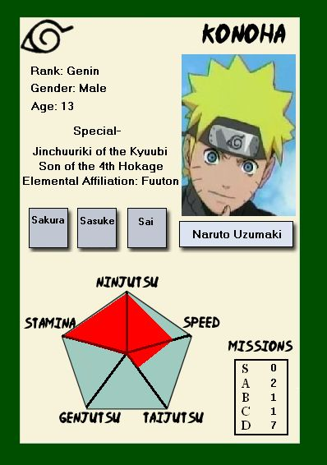

*“A Bingo Book contains information about every known ninja. It has personal information and descriptions about each person. You need it if you want to pinpoint their weaknesses in battle”*

[**] You are given a file called *bingo_book.txt*. Each row consists of the information about one ninja; their name, village, gender, description, status and signature move. Each detail is separated by a comma (,). However, some rows have an additional detail, Deserted.

Write a program that prompts the user for a name. The user should be able to retrieve all the data of the ninja with that name. If there is no one in the bingo_book.txt with the name entered, the program will issue an error message “Error: <name> not found!”

Take note of the following:

1. Input is **not case-sensitive**; the program should be able to retrieve data even if the capitalization of the input does not match.
2. You may assume that each word in a ninja’s name starts with a capital letter. The rest of the letters are in lowercase (i.e. Sakura Haruno)
3. You may use a dictionary or nested list to help you store and retrieve data from the text file.
4. You may assume that commas are only used to separate each detail, it does not appear anywhere else.

If done correctly, your output should match the following test cases: (next page)

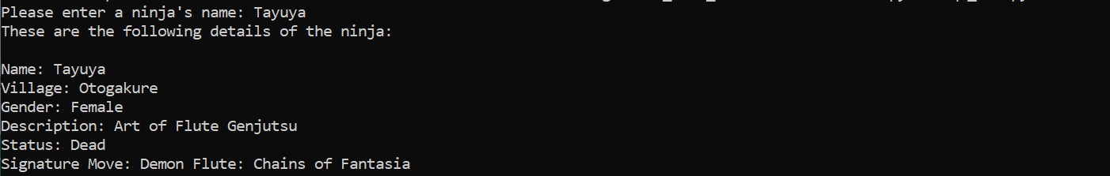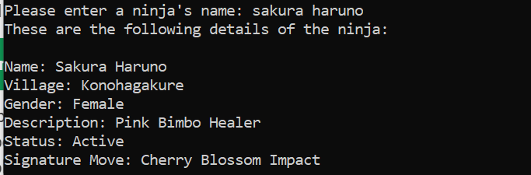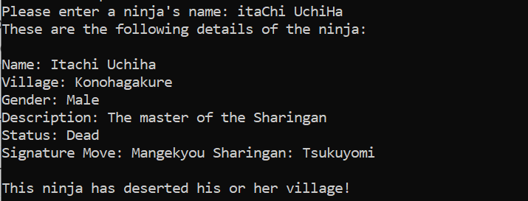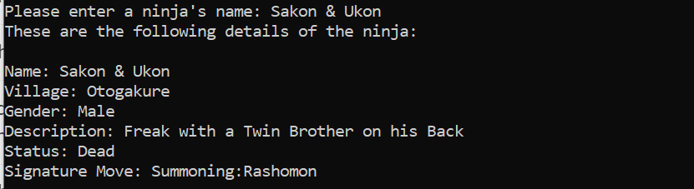

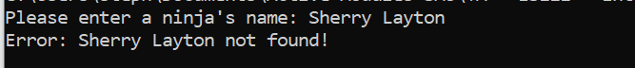

**---------------------------------------------------------------------------------------------------------------------------**

###### **Q6: Decoding Melodies with Binary**

**---------------------------------------------------------------------------------------------------------------------------**



*“Tayuya’s flute can produce sound waves that traps you in an illusion. If you can figure out her tune, you might be able to escape.”*

Each musical note has a corresponding Base-8 binary code, consisting of 3 digits containing only 0 and 1. The binary codes of each note is listed in the following table:

|  |  |
| --- | --- |
| **Base-8** | **Music Note** |
| 000 | C |
| 001 | D |
| 010 | E |
| 011 | F |
| 100 | G |
| 101 | A |
| 110 | B |

Table taken from <https://www.geognomo.com/geognomo/geotono/>

[**] Part A) Implement a function, *binary_to_music* that takes in 1 parameter:

* *binary_code* - a string containing only 0 and 1.

The function should **return** a string containing the musical notes decoded from the binary input (e.g. BGEFEAGDFA)

You may assume the following:

* The length of the binary_code string is always a multiple of 3.
* There is no need to consider other possible combinations of Base-8 binaries, the input binary_code will ONLY contain combinations shown in the table above.
* Only musical notes featured in the table will appear.

[***] Part B) Tayuya has decided to change her melody patterns by adding fake binary numbers, making it difficult for you to decode.

Implement another function, *binary_to_music2* that takes in the same parameter as

the previous function.

The function should **return** a string containing the musical notes decoded from the

binary input (e.g. BGEFEAGDFA) , same as the previous function.

The new assumptions are:

* You can **NO LONGER** assume that the length of the *binary_code* input is a multiple of 3. There could be fake numbers in the binary strings.
* You can assume that there are no other possible binary combinations, other than those mentioned in the table.
* You can assume that there are NO fake binary numbers present if the length of the *binary_code* is a multiple of 3.

Hint: You should check if the 3 binary numbers grouped together are present in the

table above. If they aren’t you know that there is a fake binary number in the string.

(Skip this part if you are stuck)

**---------------------------------------------------------------------------------------------------------------------------**

###### **Q7: Phoebe Buffay’s New Email**

**---------------------------------------------------------------------------------------------------------------------------**

**

*“Phoebe Buffay has recently gotten a new computer; with an email system and everything. However, she doesn’t know how to use it to send updates to her fans. Use your IS111 knowledge to help her out.”*

[*] Part A) Implement a function called add_receipient that takes in 2 parameters:

* email - a string containing a person’s email address
* receipient_list - a list of containing the strings of email addresses. The list can also be empty.

The function should **return** the list of email addresses, with the new email added to

the list.

[**] Part B) Write a program that prompts the user to enter email addresses.

The program should continue the prompting the user to enter emails until the user

replies with “no”.

The program will then prompt the user for a message. Once the user has entered

their message, your output should show a confirmation that shows that your

message was sent to the email addresses entered.

Your program should be able to validate the following::

* Email addresses must contain only one “@” to be valid (You can assume that the “@” is in the correct position in the email)
* Users must give correct responses to prompts [“yes”/”no”] (Responses are case-sensitive).
* The message CANNOT be empty.

If correct, your output should look like this:

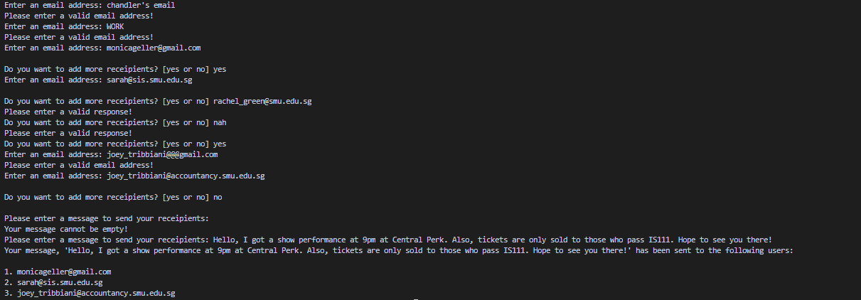

(Contact me if the expected output is not clear)

**---------------------------------------------------------------------------------------------------------------------------**

###### **Q8: Weapon Stock-taking**

###### **---------------------------------------------------------------------------------------------------------------------------**

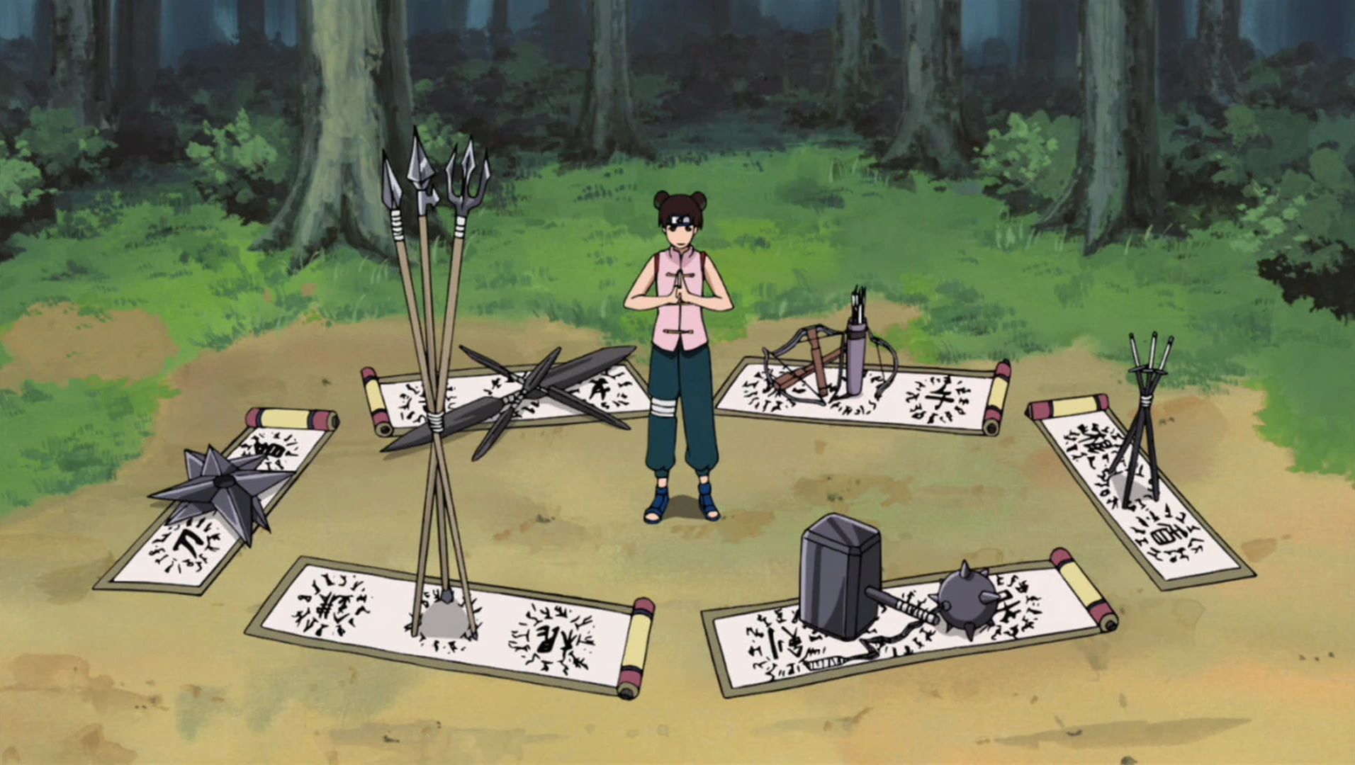

[**] You are given a dictionary weapons_dict, where the key is the name of the weapon and

the value represents the number of that weapon in the stock.Write a program that prompts the user for an action of “take” or “add”.

If anything other than the 2 actions are entered, the program prompts the user for an action again until a valid action is given.

When a valid action is given, the user is then prompted for a weapon name.

***If the action is “take”***, the program must check if the weapon exists in the stocks, and if it doesn’t, it re-prompts the user to enter a new weapon.

When a valid weapon is entered, the user is prompted for the number they would like to take. If the program detects that the input number is greater than the number of weapons present in the stocks, the user is re-prompted to enter another number.

When a successful number is entered, the number is subtracted from the stocks.

The remaining number of that weapon left is then displayed to the user. Take note that the display is different if the number of weapons left is zero.

***If the action is “add”***, the program will prompt the user for a number. The stock will then be updated with the new quantity, and displayed to the user.

If done correctly, you should be able to get the following outputs:

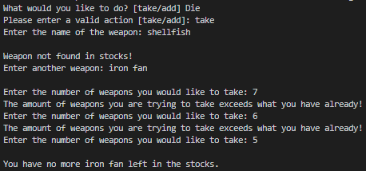

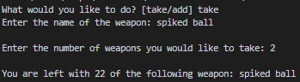

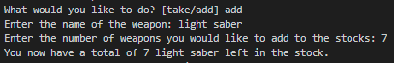

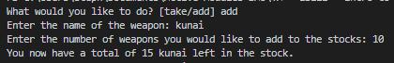

**---------------------------------------------------------------------------------------------------------------------------**

###### **Q9: Sakon’s Secret (Nested List)**

**---------------------------------------------------------------------------------------------------------------------------**



*“Sakon has a brother named Ukon, who stays nested inside his body. Likewise, a list can have one or several lists inside as an element .”*

[***] Write a function *get_nested_list* that takes in one parameter:

* *list_str* , a list in string format. This list only contains nested lists and single-digit positive integers as elements (i.e. ‘[ 1, 5, [ 2, 3, 5, [ 8 ], 5 ], 9 ]’ )

The function should **return** the list in the **first nested layer** containing ONLY integers.

For example, get_nested_list(‘[ 1, 5, [ 2, 3, 5, [ 8 ], 5 ], 9 ]’)returns [2, 3, 5, 5]. The [ 8 ] is omitted because it is not an integer.

Take note of the following assumptions:

* You can assume that there is **only ONE list** in the first nested layer (which is the one you are trying to retrieve. I.E. lists like [ 8, [ 2 ], 6, [ 3, 4 ], 0 ] will not appear, as there are 2 lists in the first nested layer.
* You can assume that the brackets are properly placed (no syntax error)
* You **CANNOT** assume the number of nested layers in the list. For example, lists like [ 2, 3, [ [ 5, 2 ], 3, [5, [ [ [ 3 ] ] ], 6 ], 8 ] can occur.
* list_str may not have standard spacing. I.E.[2,3,[5,2]] or [1, 2, 3, [5], 6] can occur.

You may take a look at q9_function_test.py to look at the test cases.

**---------------------------------------------------------------------------------------------------------------------------**

###### **Q10: Surrounded on All Sides (Multi-dimensional List)**

**---------------------------------------------------------------------------------------------------------------------------**



*“Locating the enemy is easy, setting up an ambush to surround them is harder than it looks.”*

[***] Write a function *surround* that takes in one parameter:

* *field_list -* A multidimensional array, which is a list consisting of several other lists as its elements. **All nested lists will have the same number of elements as one another**. One of the nested lists contains an ‘X’, while the rest of the elements are empty strings. The rest of the nested lists will only contain empty strings. An example would be this:

[

['', '', '', '', 'X'],

['', '', '', '', ''],

['', '', '', '', ''],

['', '', '', '', '']

]

The function will return the same list, but the ‘X’ will be surrounded by ‘O’ on all 4 sides. The returned list will look like this:

[

['', '', '', 'O', 'X'],

['', '', '', '', 'O'],

['', '', '', '', ''],

['', '', '', '', '']

]

Take note of the following assumptions:

1. There will always be a minimum of **THREE rows** in field_list.
2. You can assume that there will always **be one and only one** ‘X’.
3. The number of rows and number of elements in each nested list can vary.
4. You do not have to worry about elements that are diagonally across from ‘X’, only the 4 main sides (top, left, right and bottom) need to be blocked off with ‘O’.
5. If ‘X’ is located at the border of the field_list, you only need to surround it on the spots with empty strings.

**Hint:** First write code to find the coordinates of ‘X’. Then you should write several if statements to place the ‘O’ markers.

Note: If you can solve this question, you are amazing.



**Well done for making it to the end! If you have skipped some questions, go back and redo them. Don’t give up!**